

《计算机网络》实验报告

实 验 7 | 虚拟专用网VPN
姓 名 | 冯浩然
学 号 | 202100800378
专 业 | 电子科学与技术
班 级 | 2021级1班
学 院 | 机电与信息工程学院
指导教师 | 张瑶
课程名称 | 计算机网络
课 程 号 | 2803412
学年学期 | 2023–2024学年第1学期
实验日期 | 2023年12月05日
目录
2021级“数据通信与计算机网络” 3
实验七 虚拟专用网VPN 3
一、 实验内容： 3
二、 实验步骤： 3
（一）、easy VPN配置 3
要求一： 3
要求二： 4
（二）、隧道VPN（IPSec VPN）配置 5
要求一： 5
要求二： 5
要求三： 7
三、 实验报告要求： 7
（一） easy VPN 7
问题一: 7
（二）IPSec VPN 9
问题一 9
（二） CNNA 测试题 9
问题一: 9
四、 实验感想 13

2021级“数据通信与计算机网络”

实验七 虚拟专用网VPN

实验内容：
1、easy VPN配置
2、隧道VPN（IPSec VPN）配置

实验步骤：

（一）、easy VPN配置

要求一：
构建如下网络拓扑图。对网络进行配置，实现在内网（LAN1）的计算机访问外网（LAN3）时将内部地址转换为Router0串行端口的地址（参考实验六）。

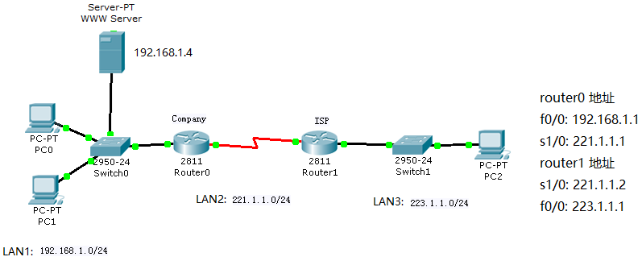
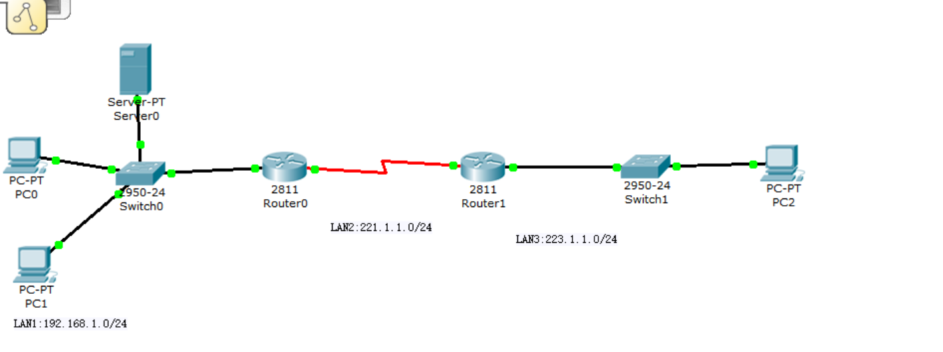
已经构建

要求二：
在NAT路由器上配置easy VPN，实现外网(LAN3)内用户通过VPN登录内网(LAN1)和访问内网主机（配置方法见附录1）。

在路由器0中进行easy VPN 的配置。
配置的登陆账号为：vpn，密码为vpn ,key为vpn，分组为vpngroup,接入网关为221.1.1.1

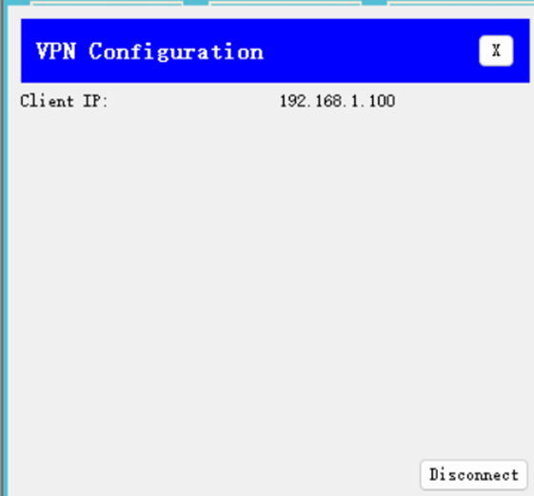
已经完成。

（二）、隧道VPN（IPSec VPN）配置

要求一：
构建如下所示的网络拓扑图。按图中标注的IP地址对计算机和路由器进行配置。
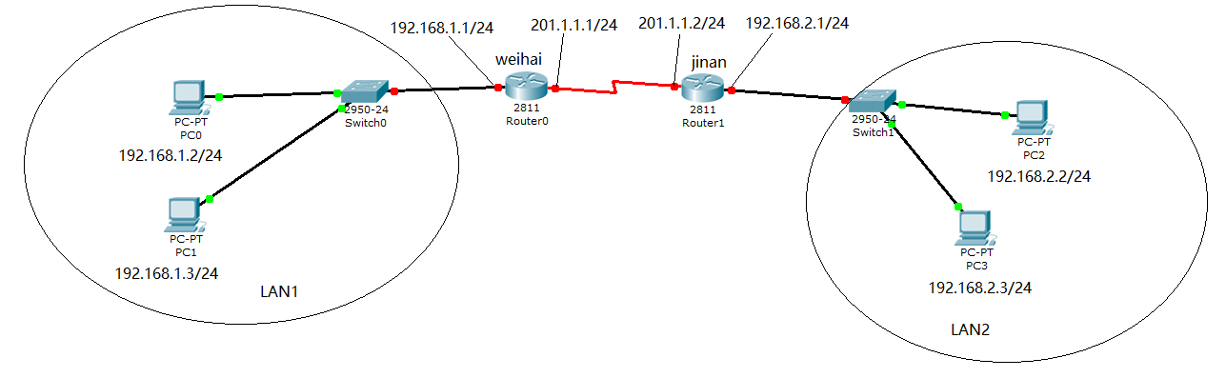

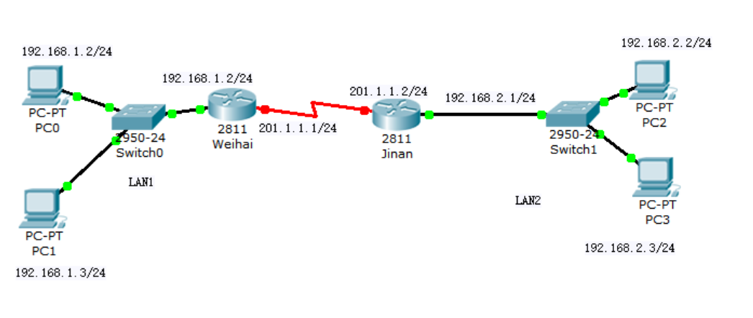
已经构建

要求二：
对网络进行配置，实现在内网（LAN1）的计算机访问外网（LAN3）时将内部地址转换为Router0串行端口的地址。

- 在 router0 和 router1 上配置 IPSec VPN，使 LAN1 与 LAN2 构成虚拟专用网，主机间采用内部地址通过外部串行链路通信。

- R0：

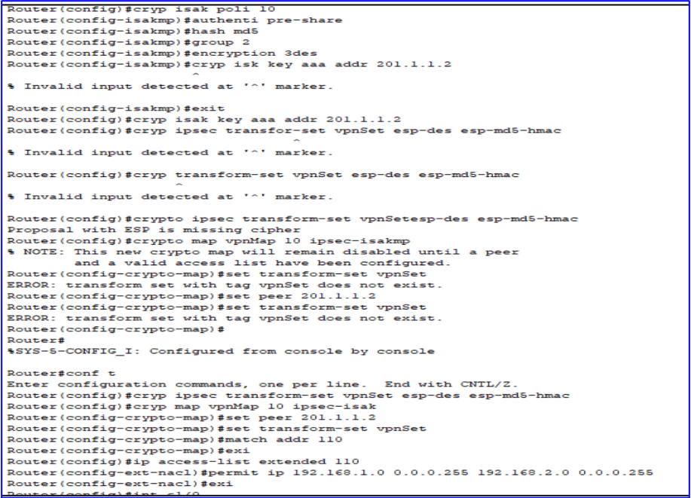

- R1：
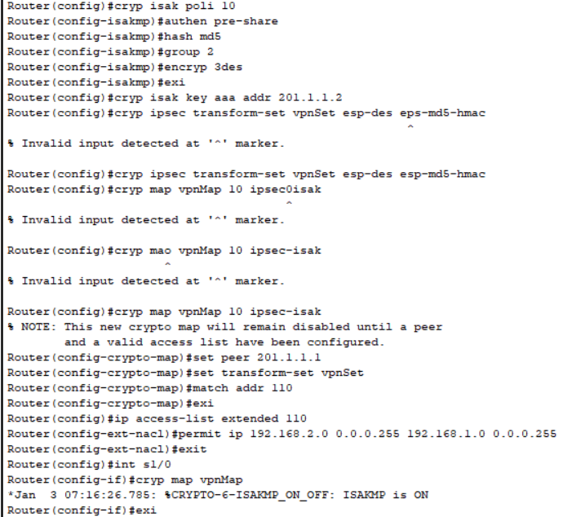

要求三：
用ping命令、tracert命令测试LAN1内主机与LAN2内主机的连通性能；

在PC2中，输入ping 192.168.1.2

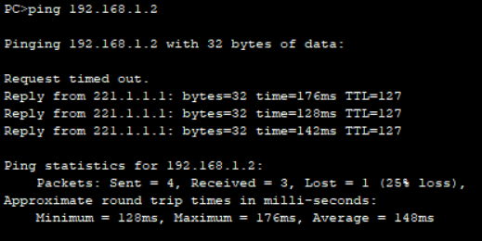

实验报告要求：

easy VPN

问题一:
简述easy VPN 配置过程。实验中如何验证easy VPN配置成功？给出实验的结果并进行说明。
配置过程已经在上方给出

验证easy VPN 配置是否成功：

路由器中
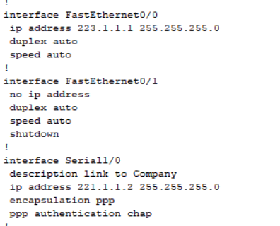
输入show run,结果如下：

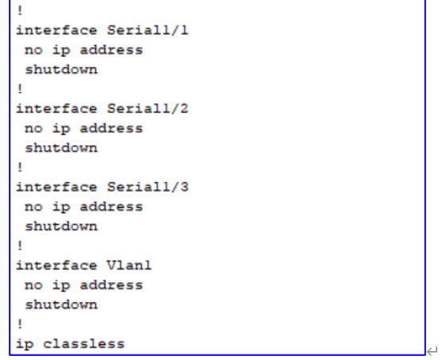

主机中检测
在外网的PC2中输入 ping 192.168.1.2,结果如下：

Easy VPN配置后，外网可以访问内网

（二）IPSec VPN

问题一
简述IPSecVPN配置过程。实验中如何验证IPSec VPN配置成功？给出实验的结果并进行说明。
配置过程和验证过程都在上文给出

CNNA 测试题

问题一:
完成下面的CCNA测试题：
B (1) You have a class C address, and you want to setup five subnets with 18 hosts per subnet. What is your subnet mask?
A. 255.255.255.128 B. 255.255.255.192
C. 255.255.255.224. D. 255.255.255.240
B (2) Does every TCP/IP host install the ICMP protocol?
A. TRUE B. FALSE
A C E(3) Which characteristics below are contained in Layer 4 of the OSI model? (choose three)
A. Connection oriented: TCP/IP B. Non acknowledgement UDP
C. Three way handshake TCP/IP D. Route selection: IP
E. sliding window: UDP
C (4) Which command can allow you to configure the IP address on one router’s interface?
A. router(config-if)#ip address 163.45.67.89 mask 255.255.224.0
B. router(config-if)#ip 163.45.67.89 255.255.224.0
C. router(config-if)#ip address 163.45.67.89 255.255.224.0
D. router(config-if)#ip 163.45.67.89 mask 0.0.0..255
E. router(config-if)#ip address 163.45.67.89 mask 0.0.0.255
C (5) Which prompt will be used in privileged model?
A. Router (config)# B. router> C. Router# D. Router(pri)#
B (6) PC A and PC B are on the same Ethernet LAN, you want to ping PC B from PC A, which protocol request will be used to looking for PC B’s MAC address?
A.RIP B. ARP request C. RARP request D. MAC request
B (7) What does the ‘base’ mean in the description as “10Base-T”?
A. It means the signaling method for communication.
B. It means the type of media.
C. It means the speed of the signal transmission.
D. It means the lowest way switch can used.
C (8) Which of the following form is a valid MAC address?
A. 161.207.2.236 B. 26-43-00-72-66
C. 00.00.12.34.DE.BE D. 0000.12.34.DE.BE
A C E(9) What are true descriptions about layer 2 bridges and switches? (Choose three)
A. Both bridges and switches can increase collision domains.
B. Switches are based on software.
C. Switches have more number of ports than most single bridges.
D. Bridges are faster than switches.
E. Both bridges and switches are layer 2 devices.
F. Bridges are layer 1 devices.
D (10) Which of the following shows the correct command to configure RIP as the routing protocol?
A. Router#rip. B. Router>rip.
Network 192.168.1.0 Network 192.168.0.0
C. Router(config-if)#router rip. D. Router(config)#router rip.
Network 192.168.0.0 255.255.255.0 Network 192.168.1.0
D (11) Which of the following statements about RIP is true?
A. It has hop counts limitation of 26
B. It uses bandwidth and hops as the metric of their path selection.
C. It is one of the link state routing protocol.
D. It sends broadcasts routing updates every 30 seconds by default.
E. It uses autonomous system numbers.
B (12) The network 192.168.1.0/24 was advertised by a neighbor router. It was also added a static route 192.168.1.0/24 manually. Which route would be used to forward traffic?
A. The RIP route. B. The static route. C. The IGRP route. D. Random.
A (13) Which of the following VTP mode can create, delete and synchronize of VLANS.
A. server mode B. client mode C. transparent mode D. VTP mode
A C (14) What is the benefit of VLAN? (Choose two)
A. It increases the number of broadcast domains
B. It increases the number of collision domains
C. To increase network security
D. To reduce switch numbers
A B D(15) What options are true regarding configuration of adding a new VLAN to an existing network? (Choose tree)
A. Must creat the VLAN. B. Naming the VLAN.
C. Must choose VLAN routing path. D. The desired ports should be assigned.
C (16) Using a class B address with a mask of 255.255.255.128, how many networks and hosts are allowed?
A. 126 networks and 512 hosts. B. 512 networks and 128 hosts per.
C. 128 networks and 512 hosts per. D. 510 networks and 126 hosts per.
C (17) What is a layer two device’s function?
A. It maintains an IP address table.
B. It maintains an MAC to IP address table.
C. It maintains a data link layer and network layer addresses table.
D. It maintains a source MAC to destination MAC’s routing table.
(18) What is the command to configure OSPF as the routing protocol on one router? Router(config) #router ospf .
C (19) Which protocol is an example of a link state routing protocol?
A. IP B. ICMP C. OSPF D.RIP version 1 E.RIP version 2
D (20) What is the benefit of using one router segmenting a network into two segments?
- It increases the number of collisions
- It decreases the number of collisions
- It decreases the number of broadcast domains
- It can prevent broadcasts between the two segments
C (21) What is the right order for information packaged during encapsulation among layers?
A. segment data packed frame B. data packet segment frame
C. data segment packet frame D. data frame packet segment
(22) What’s mean of administrative distance?管理距离是路由信息源可信度的衡量标准 What is the administrative distance for RIP? RIP的管理距离为120 。
D (23) What is the minimum legal size of an Ethernet frame?
A. 1518bytes B. 48bytes C. 24bytes D.64bytes
(24) Which protocol can be used to translate hardware address into IP address? ARP(地址解析协议)
B (25) You can configure PPP on which physical interfaces listed below?
A. Ethernet B. Synchronous Serial C. Token ring D. ISDN
D (26) Create a static route to 172.16.10.0 on Router A through serial interface 10.1.1.1.
A. Router# ip route 172.16.10.0 255.255.255.0 10.1.1.1
B. Router(config)#ip static route 172.16.10.0 255.255.255.0 10.1.1.1
C. Router(config)#ip route 172.16.10.0 10.1.1.1
D. Router(config)#ip route 172.16.10.0 255.255.255.0 10.1.1.1
(27) The value of administrative distance of following routing protocol is:
RIP 120 ; OSPF 110 ; Static routing 1 .
A (28）PPP stands for ?
(A) Point –to –Point Protocol (B) Packet-to Packet Protocol
(C) Point-to Packet Protocol (D) None of above
(29) What are the three types of switching modes?
三种类型的交换模式是：电路交换 分组交换 消息交换
C (30) What is the beginning range for a layer three multicast address?
(A) 244.0.0.0 (B) 239.0.0.0 (C) 224.0.0.0 (D) 255.0.0.0
D (31) What devices operate at the Network Layer?
A. Switches B. Bridges C. Hubs D. Routers
A (32) UDP is a connectionless transport layer protocol in TCP/IP protocol stack. Point out all the possible characteristics of UDP protocol. (Choose two)
A. Less bandwidth-intensive. B. More bandwidth-intensive
C. Non-reliable. D. More reliable.
(33) RIP protocol has a maximum of__15______ hop counts?
C E (34) Which of the following commands use ICMP protocol in layer 3? (Choose two)
A. ftp B. telnet C. ping D. pop3 E. traceroute
(35) Identify the seven-layers of the OSI reference model and point out the function of every layer.
OSI参考模型的七层是：
物理层：通过物理介质传输原始比特流
数据链路层：通过物理层在节点之间提供数据帧的无错误传输
网络层：提供不同网络上节点之间数据包的逻辑寻址和路由
传输层：在不同主机上运行的应用程序之间提供可靠的数据传输服务
会话层：管理和同步不同主机上应用程序之间的通信会话
表示层：在应用层和网络格式之间转换数据
应用层：为最终用户应用程序提供网络服务。

实验感想
这次实验不仅加深了我对VPN技术的理解，还增强了我在网络安全和数据加密领域的实践技能。
实验的第一部分涉及到easy VPN的配置。通过构建网络拓扑并实现NAT路由器的配置，我能够成功地使内网用户通过VPN访问外部网络。这个过程不仅加深了我对网络地址转换（NAT）的理解，还让我了解到VPN在保护内网数据传输过程中的重要作用。通过对easy VPN的配置验证，我能够清晰地看到VPN在网络通信中的实际应用，这增加了我的理论知识和实操能力。
在第二部分的实验中，我通过配置IPSec VPN，成功地在两个局域网（LAN1和LAN2）之间建立了虚拟专用网络。通过设置router0和router1，我实现了LAN1和LAN2之间的安全通信。使用ping和tracert命令测试连通性，不仅验证了配置的正确性，还让我对网络路径和数据包的传输过程有了更直观的认识。此外，观察IP分组首部地址变化情况，我进一步确认了VPN配置的成功，这对我理解数据加密和网络安全有着重要意义。
总的来说，这次实验不仅增强了我的技术技能，更重要的是提升了我解决实际网络问题的能力。通过实际操作和问题解决，我更加深刻地理解了虚拟专用网络的原理和应用，为我未来的学习和职业生涯奠定了坚实的基础。

